A000-MEX-Mixtec-Maize Deity-Ceramic-Black Glaze-1200 CE

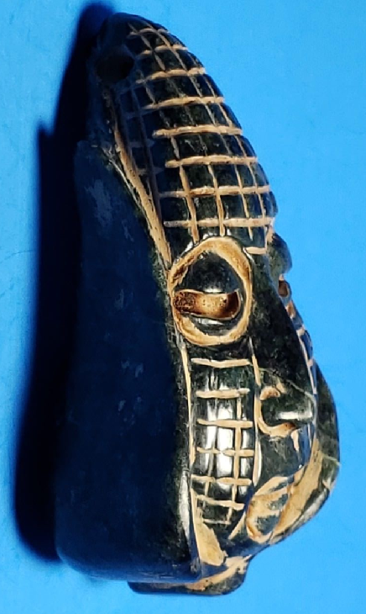 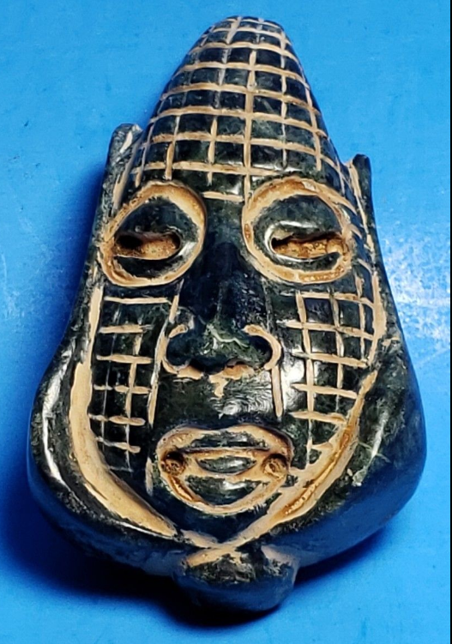 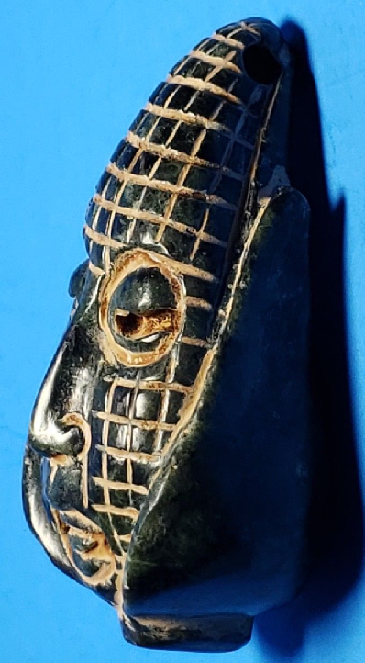

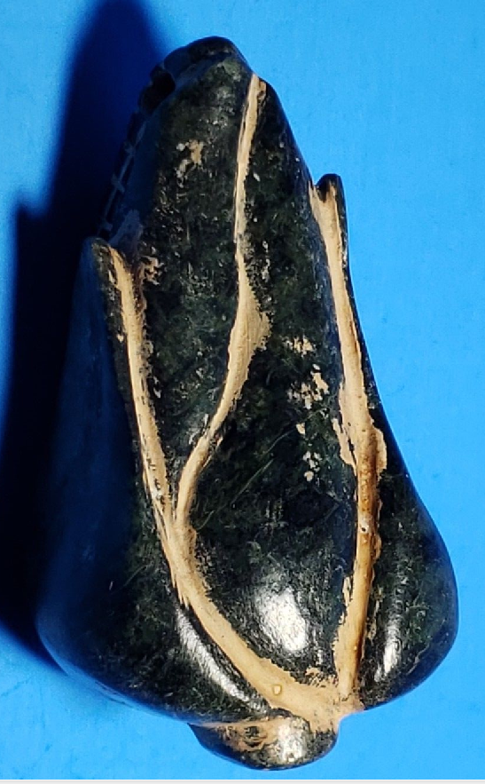

Figs. 1-4. MEX-Mixtec-Maize Deity-Ceramic-Black Glaze-1200 CE

**Case No.: 10**

**Accession No.**

**Formal Label:** MEX-Mixtec-Maize Deity-Ceramic-Black Glaze-1200 CE

**Display Description:**

[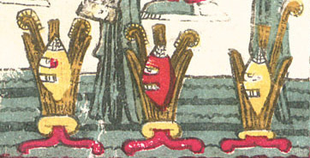](https://tlacatecco.files.wordpress.com/2008/11/borgia27_corn.jpg)

Corn, Plate 27 of the Codex Borgia

In [Aztec mythology](https://en.wikipedia.org/wiki/Aztec_mythology), Centeōtl (Centeocihuatl or Cinteotl) is the maize deity. Cintli [[ˈsint͡ɬi]](https://en.wikipedia.org/wiki/Help:IPA/Nahuatl) means "dried maize still on the cob" and teōtl [[ˈteoːt͡ɬ]](https://en.wikipedia.org/wiki/Help:IPA/Nahuatl) means "deity".[[1]](https://en.wikipedia.org/wiki/Centeotl#cite_note-dic-1) According to the [Florentine Codex](https://en.wikipedia.org/wiki/Florentine_Codex),[[2]](https://en.wikipedia.org/wiki/Centeotl#cite_note-Miller-2) Centeotl is the son of the earth goddess, [Tlazolteotl](https://en.wikipedia.org/wiki/Tlazolteotl" \o "Tlazolteotl) and solar deity [Piltzintecuhtli](https://en.wikipedia.org/wiki/Piltzintecuhtli" \o "Piltzintecuhtli), the planet [Mercury](https://en.wikipedia.org/wiki/Mercury_(planet)). Born on the day-sign 1 Xochitl.[[3]](https://en.wikipedia.org/wiki/Centeotl#cite_note-3)[[4]](https://en.wikipedia.org/wiki/Centeotl#cite_note-4) Another myth claims him as the son of the goddess [Xochiquetzal](https://en.wikipedia.org/wiki/Xochiquetzal" \o "Xochiquetzal).[[5]](https://en.wikipedia.org/wiki/Centeotl#cite_note-5) The majority of evidence gathered on Centeotl suggests that he is usually portrayed as a young man (although a debate is still ongoing), with yellow body colouration.[[2]](https://en.wikipedia.org/wiki/Centeotl#cite_note-Miller-2) Some specialists believe that Centeotl used to be the maize goddess [Chicomecōātl](https://en.wikipedia.org/wiki/Chicomecoatl" \o "Chicomecoatl). Centeotl was considered one of the most important deities of the Aztec era. There are many common features that are shown in depictions of Centeotl. For example, there often seems to be maize in his headdress. Another striking trait is the black line passing down his eyebrow, through his cheek and finishing at the bottom of his jaw line. These face markings are similarly and frequently used in the late post-classic depictions of the 'foliated' [Maya maize god](https://en.wikipedia.org/wiki/Maya_maize_god).

Like other [Mesoamerican](https://en.wikipedia.org/wiki/Mesoamerica) people, the traditional [Mayas](https://en.wikipedia.org/wiki/Maya_civilization) recognize in their staple crop, [maize](https://en.wikipedia.org/wiki/Maize), a vital force with which they strongly identify. This is clearly shown by their mythological traditions. According to the 16th-century [Popol Vuh](https://en.wikipedia.org/wiki/Popol_Vuh), the [Hero Twins](https://en.wikipedia.org/wiki/Hero_Twins) have maize plants for alter egos and man himself is created from maize. The discovery and opening of the Maize Mountain - the place where the corn seeds are hidden - is still one of the most popular of Maya tales. In the Classic period (200-900 AD), the maize deity shows aspects of a [culture hero](https://en.wikipedia.org/wiki/Culture_hero).

“We eat the Earth, and the Earth eats us.” Is a popular saying recorded in “Cosmic Jaws” by David Carrasco. Earth was created when Quetzalcoatl and Tezcatlipoca as great serpents squeezed Cipactli (the primordial monster-goddess) in half and created the land and the sky from her. She ac tually houses us and feeds us and so as we become indebted to her she eats us when we die. Then there is Tonatiuh the Sun who received the heart sacrifice as food and drink, and Tlacaelel who thought that Nahua soldiers like tasty tortillas. Numerous prayers and songs, some recorded by Sahagun in Book 6 of the Florentine Codex, describe the sacrificed warrior entering the jaws of Tlaltecuhtli, and praise his blessed state as he goes to feed the cosmos. Young warriors were thought to be like the corn god Centeotl, with the harvesting of the enemy as the ears of corn.

**LC Classification:**

**Date or Time Horizon:**

**Geographical Area:**

**Map:**

**GPS coordinates:**

**Cultural Affiliation:**

**Media:**

**Dimensions:**

**Weight:**

**Condition:**

**Provenance:**

**Discussion:**

**References:**

• *Bassie, Karen (2002). "Corn Deities and the Complementary Male/Female Principle". In Lowell S. Gustafson; Amelia N. Trevelyan.* [*Ancient Maya Gender Identity and Relations*](http://www.mesoweb.com/features/bassie/corn/)*. Westport, Conn. and London: Bergin&Garvey. pp. 169–190.*

• • *Thompson, J. Eric S. (1970). Maya History and Religion. Norman: University of Oklahoma Press.*

• • [*Taube, Karl A.*](https://en.wikipedia.org/wiki/Karl_Taube) *(1985).* [*"The Classic Maya Maize God: A Reappraisal"*](http://www.mesoweb.com/pari/publications/RT07/Maize.html) *(*[*PDF*](https://en.wikipedia.org/wiki/PDF)*). In Virginia M. Fields (volume). Fifth Palenque Round Table, 1983. Proceedings of the Fifth Palenque Round Table Conference, June 12–18, 1983, Palenque, Chiapas, Mexico. Merle Greene Robertson (general ed.) (PARI Online publication (November 2003) ed.). San Francisco, CA:* [*Pre-Columbian Art Research Institute*](https://en.wikipedia.org/w/index.php?title=Pre-Columbian_Art_Research_Institute&action=edit&redlink=1)*.* [*OCLC*](https://en.wikipedia.org/wiki/OCLC)[*12111843*](https://www.worldcat.org/oclc/12111843)*. Retrieved 2007-12-06.*

• • *Saturno, William; David Stuart; Karl Taube (2005). The Murals of San Bartolo, El Petén, Guatemala, Part I: The North Wall. Ancient America 7.*

• • *Taube, Karl; William A. Saturno; David Stuart; Heather Hurst (2010). The Murals of San Bartolo, El Petén, Guatemala, Part 2: The West Wall. Ancient America 10.*

• • *Braakhuis, H.E.M. (2009).* [*"The Tonsured Maize God and Chicome-Xochitl as Maize Bringers and Culture Heroes: A Gulf Coast Perspective"*](http://www.wayeb.org/notes/wayeb_notes0032.pdf) *(*[*PDF*](https://en.wikipedia.org/wiki/PDF)*). Wayeb Notes No. 32.*

• • *Freidel, David, Linda Schele, Joy Parker (1993). Maya Cosmos. New York: William Morrow and Company.*

• • *Taube, Karl (1998). "The Jade Hearth: Centrality, Rulership, and the Classic Maya Temple". In Stephen Houston. Function and Meaning in Classic Maya Architecture. Washington: Dumbarton Oaks Research Library. pp. 427–478.*

• • *Taube, Karl (2009). "The Maya Maize God and the Mythic Origins of Dance". In Geneviève Le Fort; et al. The Maya and their Sacred Narratives: Text and Context in Maya Mythologies (Acta Mesoamericana 20). pp. 41–52.*

• • *Looper, Matthew G. (2009). To Be Like Gods: Dance in Ancient Maya Civilization. Austin: University of Texas Press.* [*ISBN*](https://en.wikipedia.org/wiki/International_Standard_Book_Number)[*978-0-292-70988-1*](https://en.wikipedia.org/wiki/Special:BookSources/978-0-292-70988-1)*.*

• • *Taube, Karl (2005). "The Symbolism of Jade in Classic Maya Religion". Ancient Mesoamerica.* ***16****: 23–50.* [*doi*](https://en.wikipedia.org/wiki/Digital_object_identifier)*:*[*10.1017/s0956536105050017*](https://doi.org/10.1017%2Fs0956536105050017)*.*

• • *Saturno, William; David Stuart; Karl Taube (2004). "Identification of the West Wall Figures At Pinturas Sub-1, San Bartolo, Petén". In Juan Pedro de la Porte, Bárbara Arroyo and Héctor E. Mejía.* [*XVIII Simposio de Investigaciones Arqueológicas en Guatemala*](http://www.famsi.org/reports/03101/60saturno_stuart_taube/60saturno_stuart_taube.pdf) *(PDF). Guatemala: Museo Nacional de Arqueología e Etnología.*

• • *Martin, Simon (2006). "Cacao in Ancient Maya Religion: First Fruit from the Maize Tree and other Tales from the Underworld". In Cameron L. McNeil. Chocolate in Mesoamerica. Gainesville: University Press of Florida. pp. 154–183.*

• • *Braakhuis, H.E.M. (2014).* [*"Challenging the Lightnings: San Bartolo's West Wall Mural and the Maize Hero Myth"*](http://www.wayeb.org/notes/wayeb_notes0046.pdf) *(*[*PDF*](https://en.wikipedia.org/wiki/PDF)*). Wayeb Notes No. 46.*

• • *Roys, Ralph L. (trans.) (1967). The Book of Chilam Balam of Chumayel. Norman: University of Oklahoma Press.*

• *Zender, Marc (2014). "On the Reading of Three Classic Maya Portrait Glyphs". The PARI Journal.* ***15****: 1–14.*

[**The Maize God (God E)**](http://ancientmayalife.blogspot.com/2012/10/the-maize-god-god-e.html)

*Author's note: this post was last updated on 11/19/17.*

|  |
| --- |
| [https://3.bp.blogspot.com/-Wz37Kw2vmmo/WhIz77tqoDI/AAAAAAAAA_Y/saMJFt1aerIymt1orBL7pgEiHVSTipPZACLcBGAs/s640/composite.png](https://3.bp.blogspot.com/-Wz37Kw2vmmo/WhIz77tqoDI/AAAAAAAAA_Y/saMJFt1aerIymt1orBL7pgEiHVSTipPZACLcBGAs/s1600/composite.png) |
| *Composite image by the author, made from photos of figurine made in the 700s AD, in Mexico.It shows the Maize God wearing jewelry and a headdress, in a corn plant. Source photos from the Metropolitan Museum of Art.* |

Fertility, [jade](http://ancientmayalife.blogspot.com/2011/07/jade-precious-stone-of-maya.html), beauty, and the idea of being young were all things the ancient Maya thought when they thought of the Maize God; they also would draw his head when they wanted a symbol of corn -- or a symbol of cacao. Other than all of these things, this god was connected to rulers and may have had several aspects. The ancient Maya believed in a lot of gods, and the Maize God -- which you may see called God E -- was definitely a major one in their religion.  
  
Appearance   
The Maize God was drawn as young and with a head that looks somewhat like an ear of corn. That is, his head was elongated and he only had hair right on top of his head. He is also drawn with a whole bunch of jewelry made from jade, and on his belt there's an ornament that you may see called the "xook monster." (The "xook monster" looks like the head of a shark that was drawn with a lot of artistic license.)

|  |
| --- |
| [https://3.bp.blogspot.com/-rmw9KwdAQVo/WhIv2W5udUI/AAAAAAAAA_A/OWDnMzQDDbwc-z5jijGGHTsEjNsoYYbkACLcBGAs/s200/b.jpg](https://3.bp.blogspot.com/-rmw9KwdAQVo/WhIv2W5udUI/AAAAAAAAA_A/OWDnMzQDDbwc-z5jijGGHTsEjNsoYYbkACLcBGAs/s1600/b.jpg) |
| *This stucco artifact was made between 100 BC and 100 AD. It comes either from Mexico or Guatemala. From LACMA, which  calls it an "architectural medallion."* |

The ancient Maya also liked to draw images of the Maize God wearing a netted "skirt" of jade that goes down to the middle of his thighs. This "skirt" might be a symbol of something else. Another is that it represents a turtle shell, which is a symbol representing the earth. (The turtle shell symbol is also part of a myth about the Maize God that the ancient Maya seemed to like a lot. See below for more in The Myth of the Maize God section.)  
  
 How the ancient Maya drew the Maize God didn't always stay exactly the same. For a while, in the Early Classic (the first part of the Classic Period,) the ancient Maya liked to draw the Maize God so that his mouth was open and his two front teeth stuck out. They moved away from this, and eventually began to like drawing him with a closed mouth.  
  
The Two Aspects  
This description of the Maize God -- being young, with a long head and having only some hair -- might only apply to an aspect of the Maize God. You may know this aspect as the Tonsured Maize God. His ancient Mayan name might be Juun Ixiim, which has several translations including "One Grain Corn."  
  
The reason why the description might be only for the Tonsured Maize God is because of what the ancient Maya who lived in the Classic Period never seemed to want to put on their pottery: images of another possible aspect, the Foliated Maize God. (Though they did use his name glyph as a "head variant" for the number eight.)  
  
The Foliated Maize God, whose name might be Ajan, was connected to corn plants that were fully grown. The ancient Maya drew this possible aspect with an ear of corn coming out of his head. The ancient Maya who created the four known codices -- which come from the Postclassic Period -- seem to have drawn only him.  
  
These two aspects might not even be aspects at all. There is also the belief that they were both gods on their own, though they were both gods of corn.  
Fig. 1: Tonsured Maize God as a patron of the scribal arts, Classic period

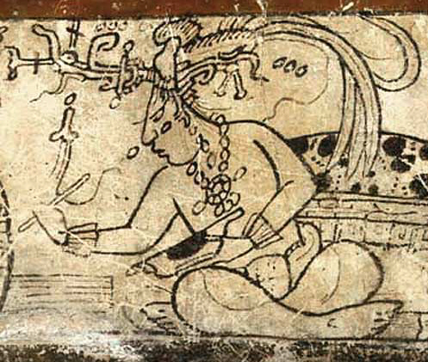

unknown Maya artist - Francis Robicsek: The Maya Book of the Dead. The Ceramic Codex, University of Virginia Art Museum (1981).

The Maize God as scribe

The Myth of the Maize God  
There is a myth of the Maize God, seen from the Preclassic Period on into the Popol Vuh. (It doesn't mean it's always the exact same myth, though.) In it, the Maize God dies, goes into the underworld, and comes back to life.

|  |
| --- |
|  |
| *The front pieces of a pair of earflares showing the head of the Maize God as a symbol of picked corn -- his close eyes mean he's dead. They were made in the 400s AD to 600s AD and might be from Guatemala. From The Metropolitan Museum of Art.* |

When they drew the Maize God going to the Underworld, which is drawn as being watery, Ancient Maya artists liked to show him going there in a canoe. The Maize God is then reborn, but as strange as it may sound, he isn't resurrected yet -- he only does that after he forces his way back above the ground. (He doesn't do it alone either -- he either has Chaak or the Hero Twins help him back out.) Before he can force his way back above ground through, women in the Underworld put pieces of jade jewelry on him -- this has to be done before he resurrects.  
  
Connections to Ancient Maya Rulers  
It seems rulers in the ancient Maya world wanted people to look at their family's rule as like the cycle of plants: when a ruler died, another one took that ruler's place. (It was supposed to be like the cycle had started over with the new ruler.)

|  |
| --- |
| https://3.bp.blogspot.com/-3g1_IitpEZQ/WhHQ8Yp0AxI/AAAAAAAAA-k/qpo-I0AlbnYdMUBPEbqU9i9hAJdzLZRawCPcBGAYYCw/s1600/a.jpg |
| *This piece of pottery is from Guatemala and was made between 300 AD and 600 AD. The ruler drawn  on it is impersonating the Maize God. From LACMA.* |

It also looks like rulers thought that they would actually have the same thing happen to them that happened to the Maize God in the myth -- so they had jade jewelry put on their bodies when they died. While alive, rulers would impersonate the Maize God for rituals, which was something they did with other gods too.  
  
An example of where you can see a ruler dressed like the Maize God (and another god, K'awiil) is the sarcophagus lid of K'inich Janaab Pakal I, a ruler of Palenque. He may either be rising up from the Underworld, rising up to the Upperworld, or perhaps falling into the Underworld.  
  
Another example of an impersonation of the Maize God is on Stela H at the site of Copan. The king impersonating the god on this stela is Waxaklajuun Ub'aah K'awiil. His netted "skirt" though goes to his ankles, which is not the normal length at all for it.  
  
Consideration: Other Aspects?  
According to Oswaldo Chinchilla Mazariegos, the Maize God had a lunar aspect. This is because there are a lot of images where he is drawn with a rabbit as well as a symbol representing the moon. This symbol, can start from one of two places: either his armpit or his back.

|  |
| --- |
| https://3.bp.blogspot.com/-DMc1JC_vjxI/WhHQ-MGO31I/AAAAAAAAA-o/0B0LWk80muEg3I6jIQgRbSgHp54SfskxgCPcBGAYYCw/s1600/b.jpg |
| *The figure on the left of this vase is a drawing of the Maize God  with that moon symbol. The vase comes from either Guatemala or Mexico  and was made between 300 AD and 900 AD. From LACMA.* |

There is a theory that the Maize God was somehow female too. This is because of the netted "skirt" that the ancient Maya liked to draw him wearing. However, this garment doesn't have any specific connection to women.  
  
References:  
[Florida Museum: Latin American Exhibit: "Mesoamerican Artifacts"; Jeffrey R. Vadala; March 23rd, 2017](https://www.floridamuseum.ufl.edu/museum-voices/latin-catalog/2017/03/23/mesoamerican-artifacts/)  
  
[Google: Books: "Beauty around the World: A Cultural Encyclopedia"; Erin Kenny, Elizabeth Gackstetter Nichols; 2017](https://books.google.com/books?id=VAUmDwAAQBAJ&printsec=frontcover&source=gbs_ge_summary_r&cad=0#v=onepage&q&f=false)  
  
[Google Books: "Art and Myth of the Ancient Maya"; Oswaldo Chinchilla Mazariegos; 2017](https://books.google.com/books?id=W3ysDgAAQBAJ&printsec=frontcover&source=gbs_ge_summary_r&cad=0#v=onepage&q&f=false)  
  
[Google Books: "Encyclopedia of the Ancient Maya"; Walter R.T. Witschey; 2016](https://books.google.com/books?id=bHcgCwAAQBAJ&printsec=frontcover&source=gbs_ge_summary_r&cad=0#v=onepage&q&f=false)  
  
[Google Books: "Mortuary Landscapes of the Classic Maya: Rituals of Body and Soul"; Andrew K. Scherer; 2015](https://books.google.com/books?id=iSN1CgAAQBAJ&printsec=frontcover&source=gbs_ge_summary_r&cad=0#v=onepage&q&f=false)  
  
[Mesoweb: "The PARI Journal" Volume XV, No. 2: "On the Reading of Three Classic Maya Portrait Glyphs"; Marc Zender; 2014](http://www.mesoweb.com/pari/journal/archive/PARI1502.pdf)  
  
[Google Books: "The Life Within: Classic Maya and the Matter of Permanence"; Stephen Houston; 2014](https://books.google.com/books?id=ois_AwAAQBAJ&printsec=frontcover&source=gbs_ge_summary_r&cad=0#v=onepage&q&f=false)  
  
[Mesoweb: "Antiquity" Volume 85; "In the path of the Maize God: a royal tomb at Nakum, Peten, Guatemala"; Jarosław Zrałka, Wiesław Koszkul, Simon Martin, Bernard Hermes; 2011](http://www.mesoweb.com/about/martin/Zralka_etal_2011_Antiquity_Nakum.pdf)  
  
[Google Books: "Death and the Classic Maya Kings"; James L. Fitzsimmons; 2009](https://books.google.com/books?id=eXMSu_g2Ae0C&printsec=frontcover&source=gbs_ge_summary_r&cad=0#v=onepage&q&f=false)  
  
[Google Books: "Maya Sacred Geography and the Creator Deities"; Karen Bassie-Sweet; 2008](https://books.google.com/books?id=ZnYCBQAAQBAJ&printsec=frontcover&source=gbs_ge_summary_r&cad=0#v=onepage&q&f=false)  
  
[Google Books: "The Ancient Maya: New Perspectives"; Heather McKillop; 2004](https://books.google.com/books?id=BmPpbB2cXu4C&printsec=frontcover&source=gbs_ge_summary_r&cad=0#v=onepage&q&f=false)  
  
[Google Books: "Archaeology of Ancient Mexico and Central America: An Encyclopedia"; Susan Toby Evans, David L. Webster (editors); 2001](https://books.google.com/books?id=6ba_AAAAQBAJ&printsec=frontcover&source=gbs_ge_summary_r&cad=0#v=onepage&q&f=false)  
  
[Google Books: "Trees of Paradise and Pillars of the World: The Serial Stela Cycle of "18-Rabbit-God K," King of Copan"; Elizabeth A. Newsome; 2001](https://books.google.com/books?id=4xkYrqbVsJUC&printsec=frontcover&source=gbs_ge_summary_r&cad=0#v=onepage&q&f=false)  
  
[Los Angeles Mission College: "Jade - The Green Gold of the Maya"; Elisabeth Wagner](https://mymission.lamission.edu/userdata/schustm/docs/Mesoamerica-%20Jade-The%20Green%20Gold%20of%20the%20Maya.pdf)  
  
  
Image Credits:  
[The Metropolitan Museum of Art: Young Corn God](https://www.metmuseum.org/art/collection/search/312915?sortBy=Relevance&amp;ft=maya+maize&amp;offset=0&amp;rpp=20&amp;pos=6)  
  
[LACMA: Architectural Medallion Depicting the Maize God](http://collections.lacma.org/node/188725)  
  
[The Metropolitan Museum of Art: Pair of Earflare Frontals](https://www.metmuseum.org/art/collection/search/317760?sortBy=Relevance&amp;ft=maya+maize&amp;offset=0&amp;rpp=20&amp;pos=3)  
  
[LACMA: Seated Ruler in the Guise of the Maize God](http://collections.lacma.org/node/1903396)

[LACMA: Cylinder Vase with Moon Goddess and Other Celestial Beings](http://collections.lacma.org/node/2115942)

Posted by [Glas Ysgrifen](https://plus.google.com/109459920353849427976) at [12:02 PM](http://ancientmayalife.blogspot.com/2012/10/the-maize-god-god-e.html) [0 comments](http://ancientmayalife.blogspot.com/2012/10/the-maize-god-god-e.html#comment-form)

[Email This](https://www.blogger.com/share-post.g?blogID=2081275458588792476&postID=3144122107942593831&target=email)[BlogThis!](https://www.blogger.com/share-post.g?blogID=2081275458588792476&postID=3144122107942593831&target=blog)[Share to Twitter](https://www.blogger.com/share-post.g?blogID=2081275458588792476&postID=3144122107942593831&target=twitter)[Share to Facebook](https://www.blogger.com/share-post.g?blogID=2081275458588792476&postID=3144122107942593831&target=facebook)[Share to Pinterest](https://www.blogger.com/share-post.g?blogID=2081275458588792476&postID=3144122107942593831&target=pinterest)

Labels: [ancient Maya](http://ancientmayalife.blogspot.com/search/label/ancient%20Maya), [aspects](http://ancientmayalife.blogspot.com/search/label/aspects), [Classic Period](http://ancientmayalife.blogspot.com/search/label/Classic%20Period), [Foliated Maize God](http://ancientmayalife.blogspot.com/search/label/Foliated%20Maize%20God), [God E](http://ancientmayalife.blogspot.com/search/label/God%20E), [jade](http://ancientmayalife.blogspot.com/search/label/jade), [maize god](http://ancientmayalife.blogspot.com/search/label/maize%20god), [Maya](http://ancientmayalife.blogspot.com/search/label/Maya), [myth](http://ancientmayalife.blogspot.com/search/label/myth), [Popol Vuh](http://ancientmayalife.blogspot.com/search/label/Popol%20Vuh), [religion](http://ancientmayalife.blogspot.com/search/label/religion), [resurrection](http://ancientmayalife.blogspot.com/search/label/resurrection), [Tonsured Maize God](http://ancientmayalife.blogspot.com/search/label/Tonsured%20Maize%20God)

[Older Posts](http://ancientmayalife.blogspot.com/search/label/Foliated%20Maize%20God?updated-max=2012-10-17T12:02:00-05:00&max-results=20&start=20&by-date=false)

=======================================================================================

**ORIGINAL QUESTION received from - and thanks to - *Danny, school pupil*: Where did the Aztecs store their food? *(Answered by Ian Mursell/Mexicolore)***

|  |
| --- |
| Stone sculpture representing the storage of corn/maize |
| Stone sculpture representing the storage of corn/maize |

The short answer is *‘in granaries’.*  
Famine was a constant worry to the Aztecs and their rulers. It was famine, rather than malnutrition, that proved the biggest threat to the population. Hunger was a common fact of life during the year, especially during June and July, the season between the two harvests. Worse, there could always be emergencies due to swarms of locusts and/or rodents (rats and mice), or particularly heavy rain or snow storms.  
Feeding a valley-wide population of some 1 million people was no joke, and a four-year drought around the year 1450 ended in a disastrous famine. At that time, one report tells of the three rulers of the ‘Triple Alliance’ government working together to distribute the saved-up stores of grain of 10 years and more.

|  |
| --- |
| [Filling a granary, Florentine Codex Book 7](http://www.mexicolore.co.uk/images-aus/aus_26_02_2.jpg) |
| Filling a granary, Florentine Codex Book 7 (Click on image to enlarge) |

In the case of their most important crop, corn/maize, a ‘typical’ Aztec farmer harvested ripe corn cobs in September, plucking the ears and tying them up in bundles. *‘Some of the shelled maize was kept in jars around the house, and the rest was stored in great bins made of planks or of wickerwork plastered with mortar’*(Warwick Bray).

|  |
| --- |
| [Exhibition model of wooden corn storage bin, Mexico City](http://www.mexicolore.co.uk/images-aus/aus_26_03_2.jpg) |
| Exhibition model of wooden corn storage bin, Mexico City (Click on image to enlarge) |

According to Book 8 of the famous Florentine Codex, an entire building in the city of Tenochtitlan, called the***Petlacalco***, was used to house these food storage bins. The building had its own full-time official, called a ‘Keeper of the Storehouse’.  
The Codex records that more than 2,000 measures of dried maize kernels were kept there - enough, apparently, to give a 20-year supply to the city. Other bins contained dried beans, chía (grain), amaranth seeds, coarse salt, chiles and squash seeds. Most of this food supply was, as shown in the Codex Mendoza, probably collected by the Aztecs as tribute.

|  |
| --- |
| [Maize and beans/chia storage bins - tribute from Coyolapan - in the Codex Mendoza, folio 44r](http://www.mexicolore.co.uk/images-aus/aus_26_04_2.jpg) |
| Maize and beans/chia storage bins - tribute from Coyolapan - in the Codex Mendoza, folio 44r (Click on image to enlarge) |

It was in these large food storage bins or huts, by the way, that pregnant women had to stay during the night of the ‘New Fire Ceremony’, to avoid being turned into demons! At least this all-important Aztec festival only happened once every 52 years...!

**Sources of information:-**  
• *Everyday Life of the Aztecs* by Warwick Bray (Dorset Press, 1968)  
• *Daily Life of the Aztecs* by Jacques Soustelle (Stanford University Press, 1961)  
• *Handbook to Life in the Aztec World* by Manuel Aguilar-Moreno (Facts on File, 2006)  
• *Florentine Codex*, Book 8: facsimile edition by Arthur Anderson and Charles Dibble, (Santa Fe, New Mexico, 1953)  
• *The Codex Mendoza*, Vol. II, by Frances F. Berdan and Patricia Rieff Anawalt (University of California Press, 1992)

**Picture sources:-**  
• Stone sculpture in National Museum of Anthropology, Mexico City: photo by Ana Laura Landa/Mexicolore  
• Image from the Codex Mendoza scanned from our own copy of the 1938 James Cooper Clark facsimile edition, London  
• Image from the Florentine Codex scanned from our own copy of the Club Internacional del Libro 3-volume facsimile edition, Madrid, 1994  
• Model corn bins: photo by Ian Mursell/Mexicolore